TITLE: POSTER CREATION

USER NAME: CB03D9275A8AE558C2F4B39295145681

1.Open canva App

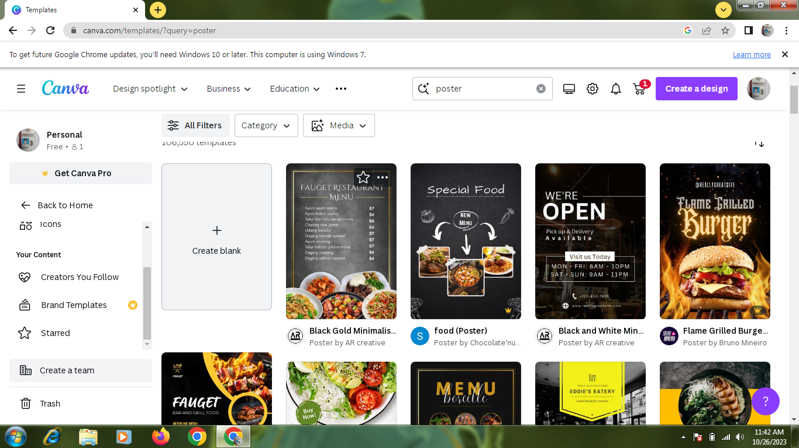

2. select a template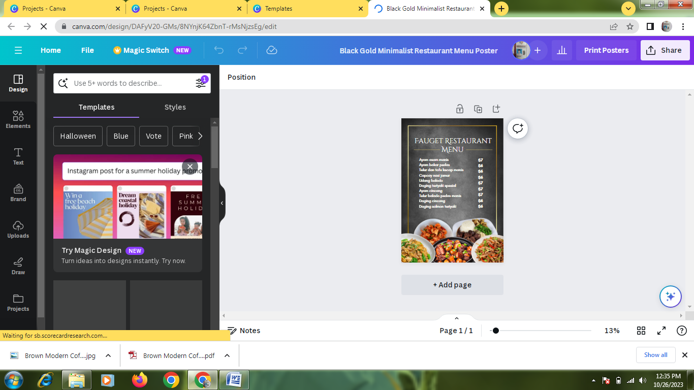

3.Edit a details

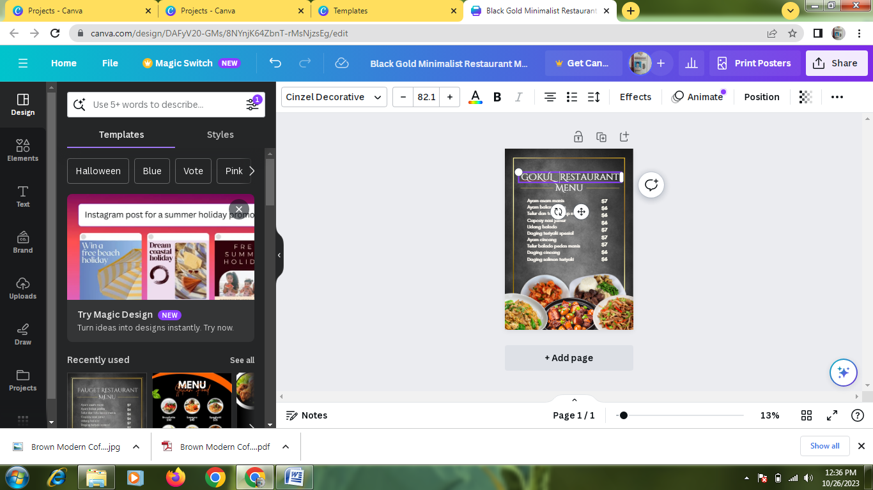

4.Upload a business related image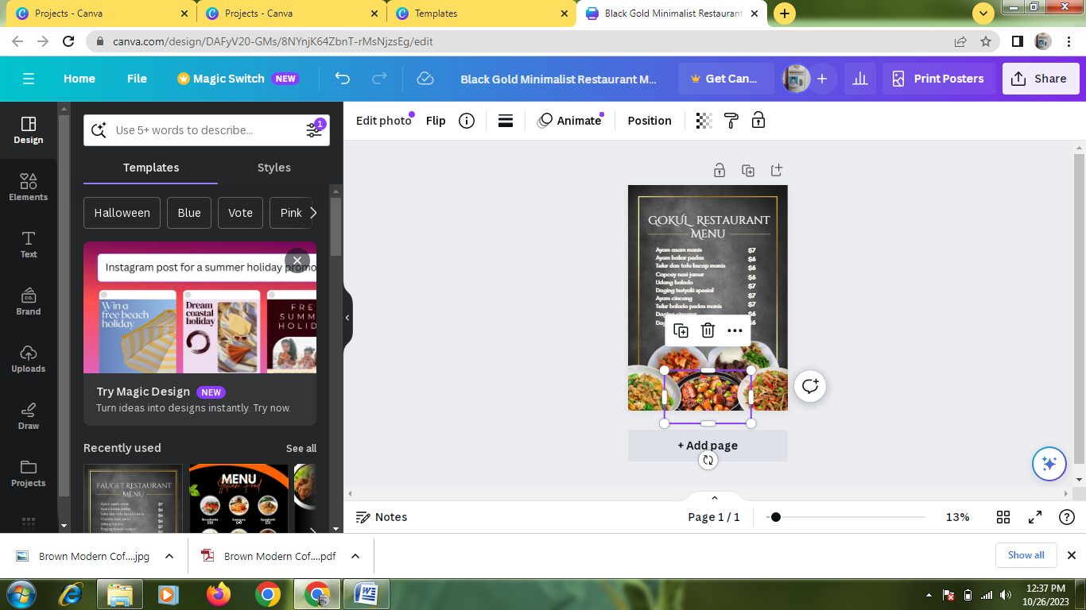

5.Pdf convert

